Version: OS 13.0 or higher

Software Packages:



Xcode

Languages:



Swift

Other Technology:



PostgreSQL



Could server

How to modify UI?

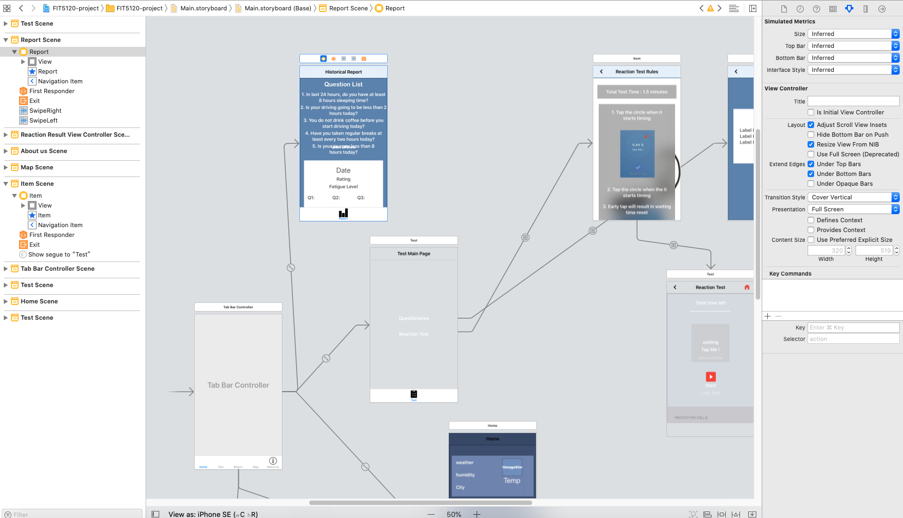

In Main.storyborad, we can modify anything we want, after added something in viewController, the constraint needs to add.

Problems (might be facing):

1.UI modified, but nothing shown when the app is running

Solution: add constraints for new elements.

2.First time install application in iPhone, could not run successfully.

Solution: iPhone -> setting -> device -> trust APP

3.Crash when iPhone running the app:

Solution: Update the system version to iOS13.0 at least

Run instruction:

iPhone: See GitHub “instruction for iPhone”

Simulators: See GitHub “instruction for simulators”

Use Case:

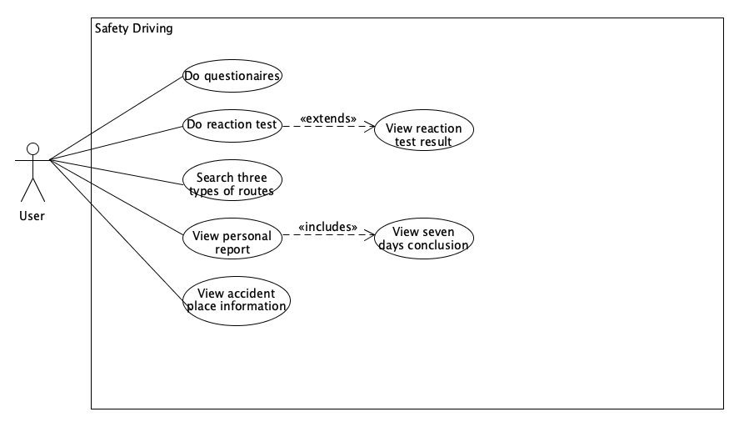

Data model:

